

**SCHOOL OF** **COMPUTER SCIENCE AND ENGINEERING**

A Project Report

on

Classification of Soil Types from Landsat-8 Images Using

Deep Learning Technique

Submitted in fulfillment of the requirements for the award of the Degree of

Bachelor of Technology

in

Computer Science and Engineering

Submitted by

K S Vighnesh - R19CS142

Katta Kamala Reethika - R19CS152

M Abhiram Reddy - R19CS171

Divya Mabbu - R19CS175

Under the guidance of

Dr. Laxmi B Rananavare

2022-2023

Rukmini Knowledge Park, Kattigenahalli, Yelahanka, Bengaluru-560064

www.reva.edu.in



**SCHOOL OF** **COMPUTER SCIENCE AND ENGINEERING**

A Project Report

on

Classification of Soil Types from Landsat-8 Images Using Deep Learning Technique

Submitted in fulfillment of the requirements for the award of the Degree of

Bachelor of Technology

in

Computer Science and Engineering

Submitted by

K S Vighnesh - R19CS142

Katta Kamala Reethika - R19CS152

M Abhiram Reddy - R19CS171

Divya Mabbu - R19CS175

Under the guidance of

Dr. Laxmi B Rananavare

2022 - 2023

Rukmini Knowledge Park, Kattigenahalli, Yelahanka, Bengaluru-560064

www.reva.edu.in

**DECLARATION**

We, Mr. K S Vighnesh, Ms. Katta Kamala Reethika, Mr. M Abhiram Reddy and Ms. Divya Mabbu students of Bachelor of Technology, belong in to School of Computer Science And Engineering, REVA University, declare that this Project Report / Dissertation entitled “Classification of Soil Types from Landsat-8 Images Using Deep Learning Technique” is the result the of project / dissertation work done by us under the supervision of Dr. Laxmi B Rananavare, Associate Professor at School of Computer Science And Engineering, REVA University.

We are submitting this Project Report / Dissertation in partial fulfillment of the requirements for the award of the degree of Bachelor of Engineering in Computer Science and Engineering by the REVA University, Bangalore during the academic year 2022-2023

We declare that this project report has been tested for plagiarism and has passed the plagiarism test with a similarity score of less than 20% and it satisfies the academic requirements in respect of Project work prescribed for the said Degree.

We further declare that this project / dissertation report or any part of it has not been submitted for award of any other Degree / Diploma of this University or any other University/ Institution.

*Signature of the candidates with dates*



*Certified that this project work submitted by K S Vighnesh, Katta Kamala Reethika, M Abhiram Reddy and Divya Mabbu has been carried out under my / our guidance and the declaration made by the candidate is true to the best of my knowledge.*

|  |  |  |
| --- | --- | --- |
| *Signature of Guide* |  | *Signature of Director of School* |
| *Date: …………….* |  | *Date: …………….* |
|  |  | *Official Seal of the School* |



**SCHOOL OF** **COMPUTER SCIENCE AND ENGINEERING.**

**CERTIFICATE**

Certified that the project work entitled **CLASSIFICATION OF SOIL TYPES FROM LANDSAT-8 IMAGES USING DEEP LEARNING TECHNIQUE** carried out under my / our guidance by **K S Vighnesh, Katta Kamala Reethika, M Abhiram Reddy and Divya Mabbu**, **R19CS142, R19CS152, R19CS171, R19CS175**,, are bonafide students of REVA University during the academic year <YEAR>, are submitting the project report in partial fulfillment for the award of **Bachelor of Technology** in Computer Science And Engineering during the academic year **2022-2023.** The project report has been tested for plagiarism and has passed the plagiarism test with the similarity score less than 20%. The project report has been approved as it satisfies the academic requirements in respect of Project work prescribed for the said Degree.

**Dr. Laxmi B Rananavare Dr. Ashwin Kumar U M**

Associate professor & Guide Director, School of CSE

**External Examiners**

**Name of the Examiner with** **affiliation** **Signature with Date**

1.

2.

**ACKNOWLEDGEMENT**

Any given task achieved is never the result of the efforts of a single individual. There are always a bunch of people who play an instrumental role leading a task to its completion. Our joy at having successfully finished our mini project work would be incomplete without thanking everyone who helped us out along the way. We would like to express our sense of gratitude to our REVA University for providing us with the means of attaining our most cherished goal.

We would like to thank our Hon’ble Chancellor, Dr. P. Shyama Raju and Hon’ble Vice-Chancellor, Dr. M Dhanamjaya for their immense support towards students to showcase innovative ideas.

We cannot express enough thanks to our respected Director, Dr. Ashwinkumar U Motagi for providing us with a highly conducive environment and encouraging the growth and creativity of each and every student. We would also like to offer our sincere gratitude to our Project Coordinators for the numerous learning opportunities that have been provided.

We would like to take this opportunity to express our gratitude to our Project Guide, Dr. Laxmi B Rananavare, for continuously supporting and guiding us in our every endeavor as well for taking a keen and active interest in the progress of every phase of our Project. Thank you for providing us with the necessary input and suggestions for advancing with our Project work. We deeply appreciate the wise guidance that sir has provided.

Finally, we would like to extend our sincere thanks to all the faculty members, staff from the School of Computer Science And Engineering.

K S Vighnesh

Katta Kamala Reethika

M Abhiram Reddy

Divya Mabbu

**Contents**

List of tables with titles and page references 6

List of illustrations / Screen Shots if any, with titles and page references. 7

List of Symbols, Abbreviation of Nomenclature 9

Abstract 10

1. Introduction 11
2. Literature Survey 12
3. Positioning 14
   1. Problem statement
   2. Product position statement
4. Project overview 15
   1. Objectives
   2. Goals
5. Project Scope 16
6. Methodology 17
7. Modules identified 20
8. Project Implementation. 21
   1. Project Flow 21

8.1.1 Data Collection

8.1.2 Pre-processing

8.1.3 Model Architecture

* 1. Architectural Design 23
  2. Sequence Diagram 25
  3. Web Application 27
  4. Description of Technology Used 36

1. Findings / Results of Analysis 40
2. Cost of the Project 46
3. Conclusions 47
4. Project Limitations and Future Enhancements 48
5. References 49
6. Copies of Articles: 50
   1. Project Proposal Showcase
   2. Conference submission

**List of Tables**

|  |  |  |
| --- | --- | --- |
| **Sl. No** | **Title of the table** | **Page Ref** |
| Table 1 | Summary of the parameters of the deep learning model | 41 |

**List of Illustrations and Screenshots**

|  |  |  |
| --- | --- | --- |
| **Sl. No** | **Title of the Illustration** | **Page Ref** |
| Fig. 1 | Five stage implementation plan | 17 |
| Fig. 2 | Flow diagram of the project | 21 |
| Fig. 3 | Natural Color Image | 22 |
| Fig. 4 | Architecture of the Deep CNN | 23 |
| Fig. 5 | Sequence diagram of the project | 25 |
| Fig. 6 | Alluvial soil Image from satellite | 40 |
| Fig. 7 | Processed Alluvial soil Image | 40 |
| Fig. 8 | Black soil Image from satellite | 40 |
| Fig. 9 | Processed Black soil Image | 40 |
| Fig. 10 | Desert soil Image from satellite | 40 |
| Fig. 11 | Processed Desert soil Image | 40 |
| Fig. 12 | Red soil Image from satellite | 41 |
| Fig. 13 | Processed Red soil Image | 41 |
| Fig. 14 | Accuracy plot for the deep learning model | 42 |
| Fig. 15 | Loss plot for the deep learning model | 42 |
| Fig. 16 | Snapshot of the Web Application | 43 |
| Fig. 17,18 | Snapshot of the Web Application once a valid image is processed | 44 |
| Fig. 19 | Snapshot of the Web Application throwing an error for inputting an invalid image | 45 |

**List of symbols, Abbreviations of Nomenclature**

|  |  |
| --- | --- |
| **Abbreviation** | **Full form** |
| CNNs | Convolutional Neural Networks |
| Landsat | Earth Resources Technology Satellite (ERTS) |
| GIS | Geographic Information Systems |
| ReLU | Rectified Linear Units |

|  |  |
| --- | --- |
| **Symbol** | **Representation** |
| Sigma | **𝜮** |
| Modulus | **| |** |

***Abstract:***

*Today, with advances in remote sensing technology and geographic information systems (GIS), there are new ways to predict soil types and their spatial distribution accurately and inexpensively. A novel aspect of this work is the integration of LANDSAT satellite imagery data and GIS to assess land information and perform soil classification using deep neural networks. The approach used here focuses on identifying soil types from satellite imagery using deep convolutional neural networks. As you know, all land areas in the world have different soil types. However, the physical and chemical properties of soils change over time due to regional changes as well as events such as deforestation and chemical waste addition. By analyzing satellite data, we aim to create a mechanism for classifying different soil types based on their physical and chemical properties. In this experiment, four basic soil types available in India are considered: alluvial, black, desert and red. The image displayed here is a high-resolution image acquired by the LANDSAT-8 satellite. The survey was conducted using a number of annotated images of each soil type taken at different times. A deep convolutional neural network was used to create a model to classify different soil types. A web interface is created to enable user to upload the image and get classified result as an output along with crop suggestions.*

*Keywords: - Deep CNN, LANDSAT-8, Image Segmentation, Soil Classification, Satellite Image Processing, Deep Learning*

**1. Introduction**

Soil is as important a natural resource as air and water. Soils come in many forms around the world. Different soils have different physical properties. The diverse behavior and physical properties of soils meet multiple agricultural needs. Soil surveys represent a critical source of information for sustainable agriculture and land management. These surveys involve mapping the soil using factors that influence management activities such as drainage, erosion control, tillage, and nutrition, which necessitate a comprehensive soil profile.

Due to the sheer volume of observations to be made, conventional approaches, including ground surveys, are very costly and time-consuming. However, advancements in computer and information technology have introduced new techniques and tools that can perform these computational tasks efficiently. With the rapid progress of remote sensing technology and Geographic Information Systems (GIS), it has become possible to estimate soil types and spatial distributions at a reasonable cost with high accuracy. These remote sensing techniques facilitate real-time and spatial evaluation of soil content.

Hence, in this research, we present a methodology that integrates remote sensing techniques with image processing tools to accurately identify diverse soil types and predict their behavior and physical parameters. The primary objective of this project is to assess the viability of incorporating remote sensing data in conjunction with image processing techniques for soil identification.

**2. Literature Survey**

[1] Several developing countries still encounter challenges with regional land use planning and monitoring. An effective solution utilizing remote sensing technology is required to capture and assess remotely sensed data. The results obtained from employing Convolutional Neural Networks (CNN) as a land cover classifier model on Sentinel-2 satellite imagery can provide valuable insights.

[2] This research paper utilizes LANDSAT image data and GIS methodologies to evaluate land information and soil classifications in the Vellore District and provide fertilizer recommendations for the study region. The initial step involved applying the k-means clustering technique to segment the sample region based on color, which served as a data preparation process. The subsequent categorization was performed using the closest neighbor decision rule on the k-segmentation clusters. Finally, the optimal fertilizer for the best soil was determined by analyzing soil color with the help of classified data.

[3] has used the k-means clustering technique to conduct pixel-based segmentation on a satellite picture from the Sentinel 2 remote sensing satellite. The generated areas from the clustering procedure are categorized according to a minimal distance decision criteria.

[4] The objective of this research project is to develop a system that can cluster satellite data for classification. The key steps involve converting the image from RGB to Lab* grayscale and then applying k-means clustering to classify the colors in the ab space. Subsequently, the k-means clustering technique is used to label each pixel in the image. These labels are then utilized to generate segmented images based on color, resulting in distinct categories such as Greenland, water, urban, and others.

[5] A novel approach is proposed in this research to utilize deep neural networks for classifying different types of soil and predicting their behavior and physical characteristics based on satellite images. The researchers employed neural networks to develop a deep network specifically for identifying soil types. Distinguishing water, ice, and land regions represents a critical remote sensing task that involves assessing the existence of water and ice on the Earth's surface. Conventional remote sensing methods, such as thresholding, spectral analysis, and statistical approaches, may not always produce globally consistent classification outcomes.

[6] As per the proposal, the model exhibits superior performance compared to existing advanced models such as UNet and Deep-Water Map when applied to medium-resolution satellite images, specifically Landsat-8 images.

[7] In this study, a novel approach is suggested for predicting monocot crop yield using the XGBoost algorithm, which analyzes factors such as NDVI, EVI, SAVI, temperature, precipitation, etc. The results reveal that the XGBoost algorithm is capable of extracting meaningful trends and accurately predicting monocot crop yield, as evidenced by a root mean square error (RMSE) coefficient of variance of 1.59.

[8] This research paper suggests a soil moisture classification model that utilizes affordable sensors instead of costly ones, which is more practical for agricultural wireless sensor networks. The model is built on the Support Vector Machine (SVM) algorithm and considers the fluctuations in soil and atmospheric temperature throughout the day. Thorough training and testing of the model showcase its ability to accurately classify soil moisture with high precision, making it a viable and practical alternative for agricultural applications.

[9] A new technique for measuring soil moisture in the Kairouan plain, a semi-arid agricultural region with limited water resources, is presented in this study. The researchers employed the Water Cloud Model (WCM) and calibrated it using a dataset that included Sentinel-1 and Sentinel-2 time series data and ground measurements obtained during the cereal crop cycle from December to March. To differentiate between irrigated and non-irrigated fields, a combination of Support Vector Machine (SVM) and Decision Tree classifications was utilized. The proposed approach achieved an overall classification accuracy of approximately 77% as demonstrated by the annual irrigation map. This study emphasizes the significance of integrated water resources management in regions where water scarcity is a pressing concern.

[10] This study explores the potential of Sentinel-2 data in identifying soil texture classes by exploiting the strong correlation between environmental variables and soil properties. The research utilized the SHAP (SHapley Additive exPlanations) method to visualize the significance of different variables and their association with the target variable. The results demonstrate that Sentinel-2 data plays a crucial role in explaining the variation of soil texture classes, particularly for sandy, loamy, and clayey soils. Moreover, the SHAP method was employed to present the decision-making process of the machine learning model, revealing the vital role of elevation, stratum, and red-edge factors in predicting soil texture classes. This research provides valuable insights into the potential applications of Sentinel-2 data in digital soil mapping and machine learning-assisted tasks.

**3. Positioning**

**3.1 Problem statement**

Using deep learning techniques to implement a classification strategy for classifying satellite images of soil into different soil types.

**3.2 Product Position Statement**

This model can be used by Farmers to determine which crop will grow the best. Government agencies can use this to better plan the distribution of crops, construction of roads, new buildings, and stormwater management systems. Private businesses that serve farmers can use it to conduct targeted marketing, and researchers who require the data to take decisions can also make use of this model.

**4. Project Overview:**

**4.1 Objectives**

This project’s major objective is to add into practice a classification system for identifying various soil types from satellite images using deep learning techniques. The main focus of this project is to validate the four different types of soil—alluvial, black, desert, and red by making appropriate comparisons and accurately. Also to build the web interface to enable users to upload the image and get classified result as output.

**4.2 Goals**

The main goal of this project is to classify different types of soil with the help of deep convolutional neutral network (CNN) and predict the soil type and properties from the satellite image.

**5. Project Scope**

With the help of deep convolutional neural networks, we created a model for classifying soil types using LANDSAT-8 images that can be used by Farmers to determine which crop will grow the best. Government agencies can use this to better plan the distribution of crops, construction of roads, new buildings, and stormwater management systems. Private businesses that serve farmers can use it to conduct targeted marketing, and researchers who require the data to take decisions can also make use of this model.

**6. Methodology**

Our project implementation contains five stages as shown below:

.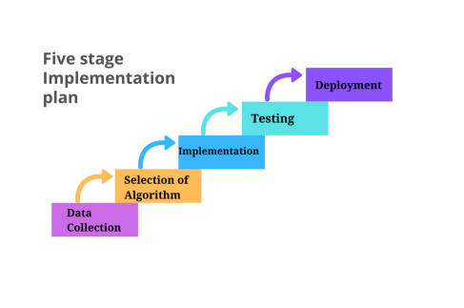

Fig. 1 Five stage implementation plan

1: Data Collection

2: Analysis and selection of Algorithm

3: Implementation

4: Testing

5: Deployment

1. **Data Collection**

This phase involves the collection of satellite images that are obtained from a geographical satellite named LANDSAT-8 and creation of the data repository by labeling those images under four different soil types.

1. **Analysis and selection of Algorithms:**

Experimentation with various methods/algorithms: Analyzing the gathered data, identifying patterns and testing the input with various algorithms, and drawing insights from them. This step involves studying different algorithms that can be used to classify the images based on their soil types. It also involves analyzing those traditional algorithms' efficiencies and proposing a suitable algorithm to get the work done.

* 1. **Traditional machine learning methods**

**K- Means clustering algorithm:**

K-means clustering is an unsupervised learning approach that uses certain features to divide a given data set into k clusters. The algorithm's basic idea is to start by defining k random centers, one for each cluster. Since the results are dependent on the initial centers selected at random these centers should be defined as far apart as feasible. The algorithm is designed to minimize the objective function.

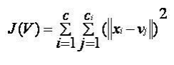 - (1)

Where,

‘||xi – vj ||’ is the Euclidean distance between xi and vj.

‘ci’ is the number of data points in the ith cluster.

‘c’ is the number of cluster centers.

**K- Nearest Neighbor Algorithm:**

This is a supervised machine learning approach that uses labeled input data to train a function that generates valid results when given with new unlabeled input data. This algorithm is based on the idea that similar items occur neighboring.

**2.2 Deep Learning method**

There are three major types of neural networks that serve as the foundation for most deep learning pre-trained models:

* Artificial Neural Networks (ANN)
* Convolution Neural Networks (CNN)
* Recurrent Neural Networks (RNN)

We have chosen Deep CNN for implementing our project.

The underlying reasons for preferring the Convolution Neural Network are:

* The objective is to extract relevant features to address a multi-class classification problem.
* This entails identifying the spatial distribution of the soil regions in the image and characterizing their chemical and physical properties.
* The extracted features will be utilized to create meaningful feature maps for upcoming soil type classification networks.

A convolutional neural network (CNN) typically comprises three types of layers:

* Convolutional layer,
* Pooling layer, and
* Fully connected layer.

Each of these three types of layers in a convolutional neural network has different parameters that can be optimized and performs a distinct task on the input data.

**Convolutional Layers:** In a deep CNN, convolutional layers are the layers where filters are applied to the original image or to additional feature maps. The majority of user-specified parameters in a convolutional neural network are typically found in the convolutional layers. Among these parameters, the number of kernels and the size of the kernels are considered the most important.

**Pooling layers:** Similar to convolutional layers, pooling layers also have a specific function in a convolutional neural network. They perform operations such as max pooling or average pooling, where the maximum or average value in a filter region is taken, respectively. These operations are often used to reduce the dimensionality of the network.

**Fully connected layers:** Fully connected layers play a crucial role in the final classification output of a CNN. They flatten the output from previous convolutional and pooling layers and act as a bridge between these layers and the classification output layer, which is typically a softmax layer. This process is similar to the output layer of a multi-layer perceptron (MLP).

**Implementation:**

The implementation phase involves training the model using the selected algorithm and adjusting hyperparameters to achieve the highest possible accuracy. Additionally, a website is developed to provide users with a graphical user interface for selecting images and receiving classified outputs. By optimizing the model's training and providing an intuitive user interface, the implementation phase sets the foundation for the successful deployment of the model.

1. **Testing:**

During this phase, the model is subjected to a variety of inputs to evaluate its performance and accuracy in producing the desired outputs. Both functional and non-functional testing are conducted, including testing against the user interface to ensure that the model meets the intended requirements.

1. **Deployment:**

The deployment phase involves making the product available to users after conducting thorough functional and non-functional testing. Once testing is complete and the model's performance is deemed satisfactory, it can be deployed for use by the intended audience. This may involve the installation of necessary software or the publication of the model on a website or application. Successful deployment is critical for ensuring that the model delivers accurate and reliable results to users.

**7. Modules Identified:**

**1. Data Collection and Pre-processing**

Data connection phase involves the collection of satellite images that are obtained from LANDSAT-8 and creation of the data repository by labeling those images under four different soil types. Pre-processing phase involves applying necessary data pre-processing techniques to scale and normalize the data before feeding it to the model for training.

**2. Training the Deep CNN Model**

This module involves training the model using a selected algorithm, such as convolutional neural networks (CNNs), and adjusting hyperparameters to optimize its performance.

During the training phase, the model is fed large amounts of labeled data to learn and improve its performance over time. As the model trains, its ability to accurately classify and identify objects within images improves. The goal is to achieve the highest possible accuracy in recognizing objects and images with the lowest possible error rate.

Adjusting hyperparameters, such as learning rate and batch size, can significantly impact the performance of the model. Fine-tuning these parameters can lead to improved accuracy and faster convergence during training. The accuracy of the trained model ultimately determines its success in real-world scenarios. Thus, selecting the right algorithm and carefully tuning hyperparameters can lead to a highly accurate and effective model.

**3. Website Development**

This phase involves providing a user-friendly interface for accessing and utilizing the trained model. The GUI enables users to interact with the model easily, allowing them to input images and receive classified outputs in a streamlined and efficient manner. The interface includes features such as drag-and-drop image upload, real-time image processing, and interactive visualizations.

**8. Project Implementation**

**8.1 Project Flow**

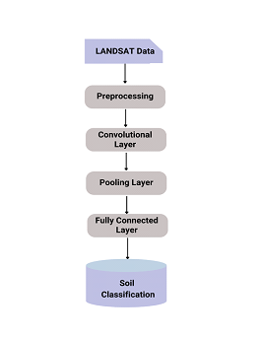

Fig. 2 Flow diagram of the project

**8.1.1 Data Collection:**

Out of the many different satellite data present on the website, we downloaded the data of the ‘LANDSAT 8’ satellite, “Landsat 8 Operational Land Imager (OLI) and Thermal Infrared Sensor (TIRS)” to be more precise. We considered Landsat 8 over Landsat 7 or other satellites because it is among the latest satellites and has maximum accuracy. The Landsat-8 satellite features two primary sensors: the Operational Land Imager (OLI) and the Thermal Infrared Sensor (TIRS). The OLI captures images using nine spectral bands across visible, near-infrared, and shortwave light wavelengths. Its high resolution enables it to distinguish various features such as urban areas, farmland, forests, and other land uses. On the other hand, the TIRS is primarily used for measuring water consumption.

The LANDSAT-8 satellite data has block sizes of 185 km x 180 km when scaled to ground level. Due to the large size of these blocks, independent images of laterite soil and mountain soil could not be obtained. Therefore, Landsat Look Natural Color Image images were downloaded for each image block, which is a natural-looking false color composite image formed using bands 6, 5, and 4. False color composites represent multispectral images produced using non-visible red, green, and blue bands as the components of the display. By incorporating bands such as near-infrared, spectral differences can be highlighted, making the data more interpretable. The downloaded data includes both temporal and spatial variations, where different blocks were chosen, and images captured at various times were downloaded for each soil region.

Sample Data:

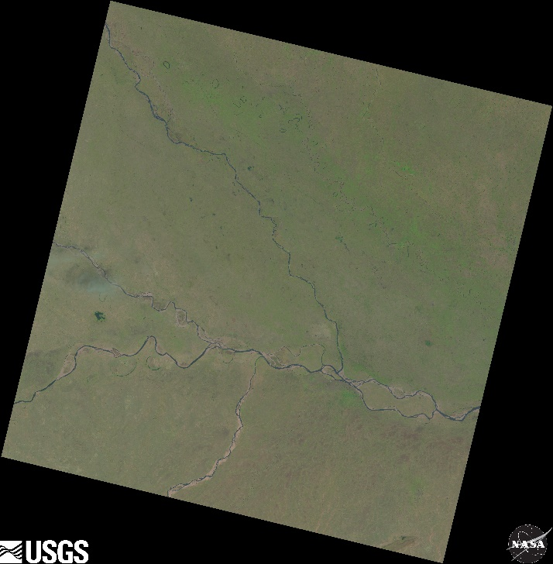

Fig. 3: Natural Colour Image

File name: LC08_L1TP_149041_20200318_20200326_01_T1

Information about data:

● Satellite: Landsat - 8

● Sensors: OLI/TIRS combined

● Processing correction level: L1TP

● Path: 149

● Row: 41

● Acquisition Date: 18/03/2020

● Processing Date: 26/03/2020

● Collection Number: 01

● Collection category: Tier-1

**8.1.2 Pre-processing:**

The original images are of high resolution and working with them as they are is quite a complex process. Hence, the images have to undergo a pre-processing step before they are fed to the model as input. The original images were of 7591×7741 resolution. Using the Python Imaging Library (PIL), we have initially reduced the image resolution to 32×32. Later, the resolution of the images was increased to 64×64, 128×128, 256×256 and so on. Finally, we have resized the images and set the new resolution size of the images to 1024×1024. Then the resized images were collected and saved into a folder and can be used as a new dataset.

**8.1.3 Model Architecture:**

This model consists of two convolutional layers. The kernel size used is 3×3 and it performs feature extraction from the image. Once the images pass the convolutional layer, they are then passed onto the pooling layer. We have used Max pooling for our model, so the maximum value from each of the convoluted images is selected and further processing is carried out. After the Max pooling, the images are then passed through fully connected layers and then finally through output layers thereby giving the output. We have also made use of the activation functions like ReLU and Softmax to transform the weighted sum of the input and decide which nodes are to be activated in the output layer.

**8.2 Architectural design**

The CNN architecture utilized in this study is shown in the figure. To accommodate high-resolution images, the input image size was reduced to 1024X1024 pixels.

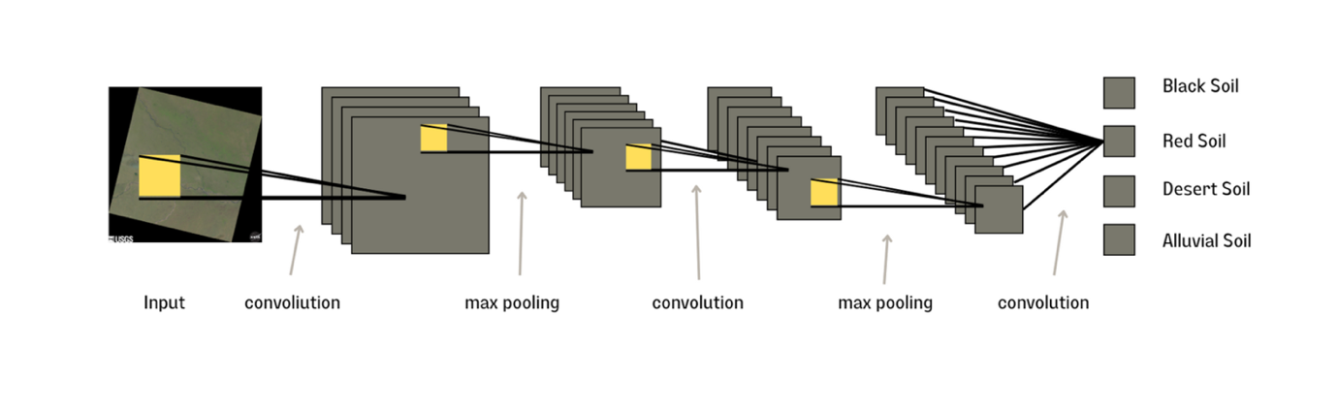

Fig. 4 Architecture of the Deep CNN

The original images were of 7591×7741 resolution. Using the Python Imaging Library (PIL), the image resolution was reduced to 32×32. Later, the resolution of the images was increased to 64×64, 128×128, 256×256 and so on.

The experiment involved testing various combinations of layers, filter sizes, and number of filters to determine the optimal model architecture. Ultimately, the model with two convolutional layers, each using a kernel size of 3x3 for feature extraction, was selected. The images were first passed through the convolutional layers and then through a max pooling layer for down-sampling. Following this, the images were passed through fully connected layers to generate the output. ReLU (Rectified Linear Unit) activation function was used in each layer, except for the output layer, which employed Softmax activation for soil classification.

The following parameters are used in the architecture of this model:

* Input Size = 1024 * 1024
* No. of convolutional layers = 2
* Filter size = 3*3
* Optimizer = Adam
* Batch size = 2
* Epochs = 10
* Activation functions = ReLU, Softmax

The first layer is a Conv2D layer with 32 filters, a filter size of (3, 3), and ReLU activation function. The layer takes an input of shape (1024, 1024, 3), representing a 1024x1024 color image with three color channels (RGB).

The second layer is a MaxPooling2D layer with a pooling size of (2, 2), which reduces the spatial dimensions of the feature maps by a factor of 2.

The third layer is another Conv2D layer with 64 filters, a filter size of (3, 3), and ReLU activation function. This layer is followed by another MaxPooling2D layer with the same pooling size of (2, 2).

The fourth layer is a Flatten layer that converts the output of the previous layer to a 1D array. This is followed by a Dense layer with 64 units and ReLU activation function.

The final layer is a Dense layer with 4 units and a softmax activation function. The softmax function outputs a probability distribution over the 4 classes, which are the possible categories that the input image can belong to.

The model is compiled with the default 'adam' optimizer, 'categorical_crossentropy' loss function for multi-class classification, and 'accuracy' metric for evaluation. The History() object is initialized to keep track of the training metrics such as loss and accuracy for each epoch.

**Raw Data as input to the deep neural network:**

We fed the raw images to a convolutional neural network consisting of various combinations of convolutional layers, pooling layers, and fully connected layers. We conducted experiments using different combinations of layers, filter sizes, and the number of filters employed in the layers.

- (2)

Where,

Tp is True positives

Fp is False positives

Tn is True negatives

Fn is False negatives

**8.3 Sequence Diagram**

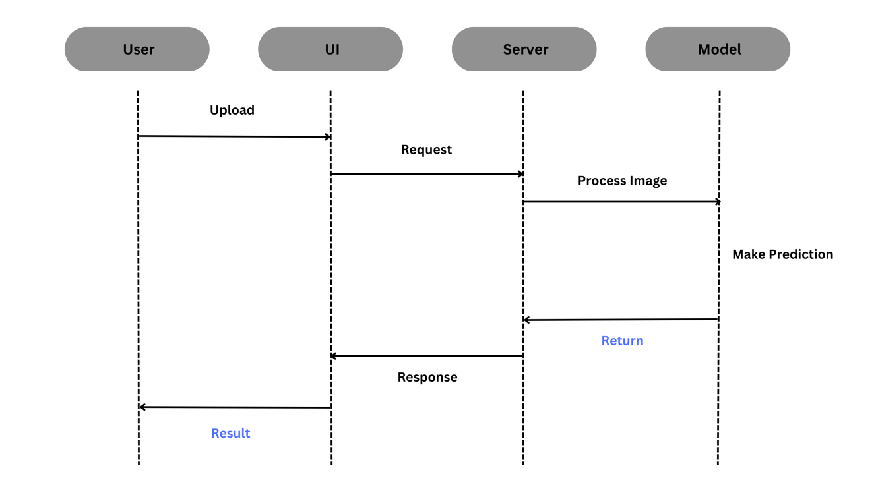

Fig. 5 Sequence diagram of the project

Fig. 5 illustrates the flow of information and processing among four main components: the user, the graphical user interface (GUI), the server, and the trained CNN model.

The user interacts with the web application by uploading an image through the GUI. The GUI sends an HTTP request to the server, which acts as an intermediary between the user and the trained model.

Upon receiving the request, the server pre-processes the image using Python libraries such as NumPy and Pillow. The pre-processing step may involve resizing, normalization, and other operations to prepare the image for inference. The pre-processed image is then fed to the trained CNN model for inference, which is implemented using deep learning frameworks such as TensorFlow.

The trained model processes the image by applying convolutional and pooling layers, as well as fully connected layers, to generate predictions about the image content. Once the model has completed processing, it generates a response containing the classification result.

The response from the trained model is then sent back to the server, which returns the result to the GUI. The GUI displays the classification result to the user. Throughout this process, Flask, an HTTP framework for Python, is used to enable communication between the GUI and server.

Overall, the sequence diagram demonstrates the complex interactions and dependencies among the different components required to deliver accurate and reliable results to users. It highlights the use of various technologies and protocols, including deep learning frameworks, Python libraries, and HTTP frameworks, to facilitate communication and processing among the components.

**8.4 Web Application**

The system contains the following modules:

* Image Input
* Classification Result
* Exception Handling
* Backend

1. Image Input

Index.html

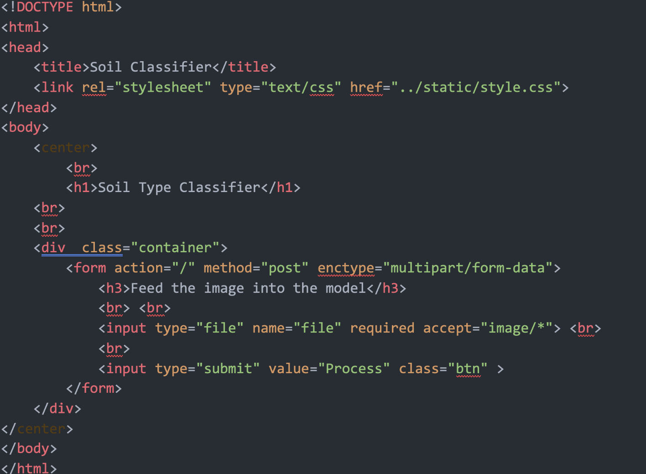

Index.html page is the user interface for a soil type classification system for taking image input. It contains a form that allows the user to upload an image by selecting a file from their local device. When the user clicks the "Process" button, the form data is submitted to the server using the POST method. The server then receives the uploaded image and uses a machine learning model to classify the type of soil present in the image. The output is then sent back to the user through the web interface, allowing them to view the classification results. External stylesheet is used to improve the visual appearance of the interface by providing styling rules for the various elements in the form.

1. Classification Result

Result.html

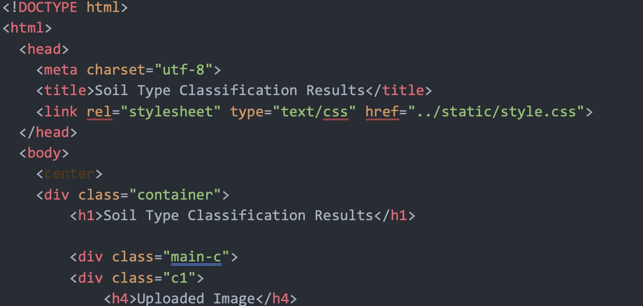

This file defines the structure and layout of the results page for the Soil Type Classification web application. It contains various HTML tags and CSS classes that are used to display the uploaded image, the confidence percentages for each soil type, the predicted soil type, and the recommended crops for that soil type.

The page is structured using div tags with specific CSS classes for formatting and layout. The uploaded image is displayed using an img tag with the source URL of the uploaded file. The confidence percentages for each soil type are displayed in a table using for loop and if else statements. The predicted soil type and recommended crops are displayed using paragraph and unordered list tags respectively.

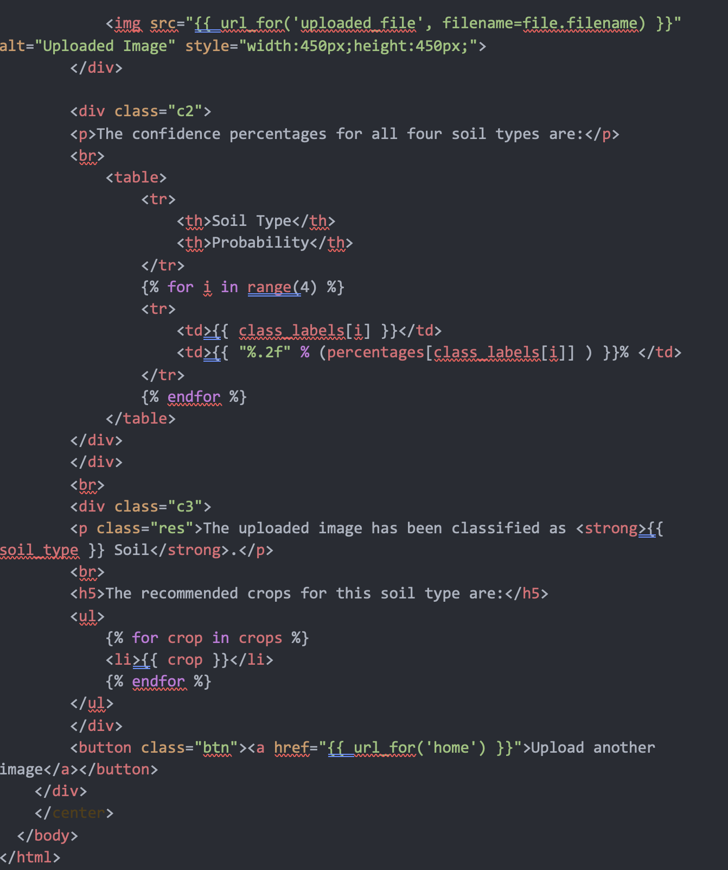

A button with a hyperlink to the home page is also provided, allowing users to upload another image. This HTML code is integrated with Python Flask to render the web page with the predicted results for the uploaded image.

1. Exception Handling

When the user tries to upload an irrelevant image (which is not a satellite image) the system throws the following error prompting the user to upload a relevant image.

Error.html

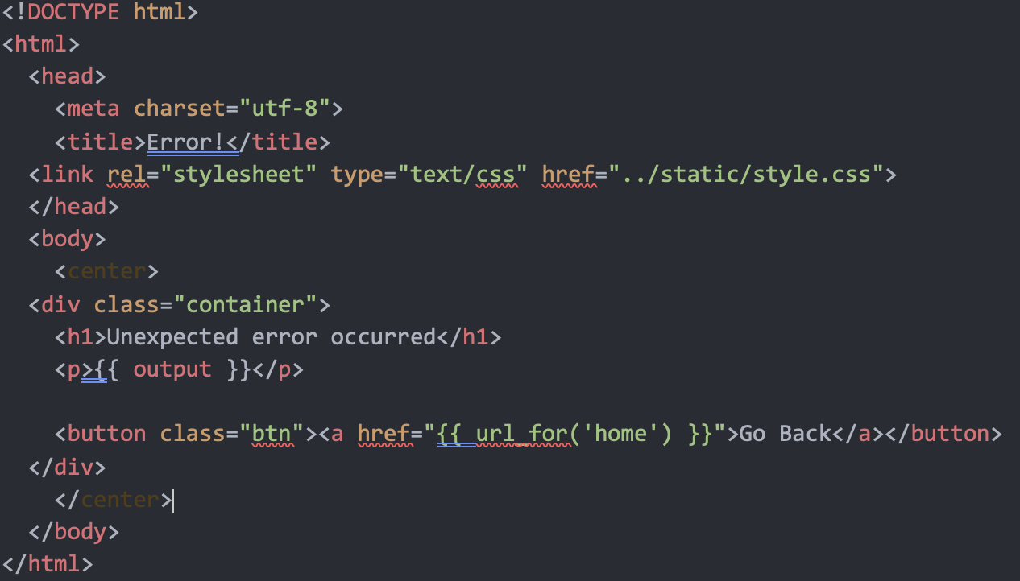

The `error.html` file is an HTML document that displays an error message when an unexpected error occurs in the web application. The file includes a title tag and a reference to a CSS stylesheet. The body of the document contains a centered container with an h1 tag displaying the error message and a paragraph tag showing a detailed error output message. Additionally, a button is included in the container that redirects the user to the home page of the web application when clicked.

1. Backend
2. **Import modules:**

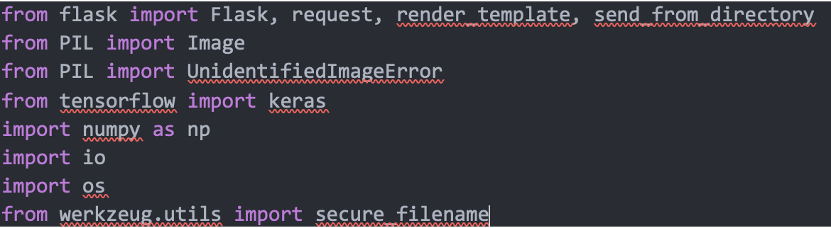

The first set of lines imports the necessary modules and packages required for the web application to work. These include the Flask framework for creating web applications, the PIL library for image processing, the Tensorflow library for machine learning, and the Werkzeug utility library for handling file uploads.

**2. Flask App Initialization:**



A new Flask application instance is created, and the name of the app is set as `__name__`.

**3. App Configuration:**



A configuration variable is set as `UPLOAD_FOLDER` to the name of the folder where uploaded images will be stored.

**4. Crop Map:**

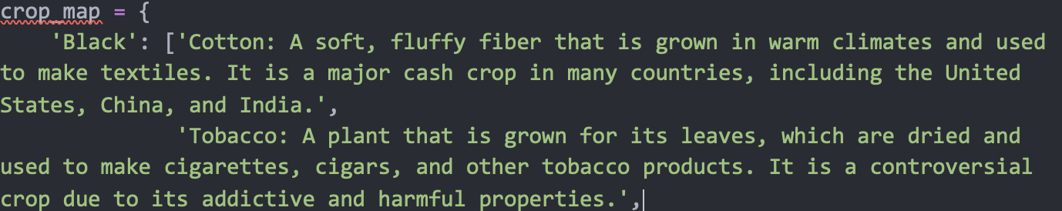

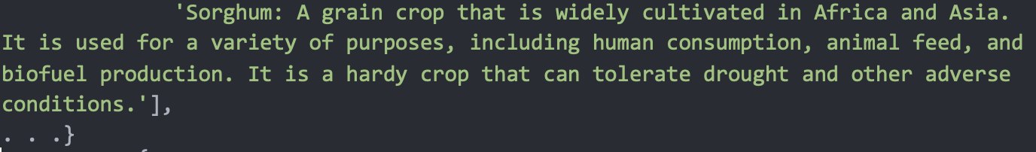

The crop_map dictionary maps each type of soil to a list of crops that are commonly grown in that type of soil. This dictionary will be used to display crop recommendations to the user based on the type of soil in the uploaded image.

**5. Class Labels:**



The class_labels list is a list of the 4 types of soil that the model is trained to classify. This list will be used to interpret the output of the model, which will be a number between 0 and 3 that represents the predicted class label.

**6. Model Initialization:**



The pre-trained machine learning model is loaded from the disk. This model is trained to classify soil types based on the features extracted from input images. The model will be used to classify the soil type of the uploaded image.

**7. Utility Function:**



The `allowed_file()` function takes a filename as input and returns True if the file extension is a valid image extension (i.e., .jpg, .jpeg, .png, or .gif).

**8. Flask Routes:**

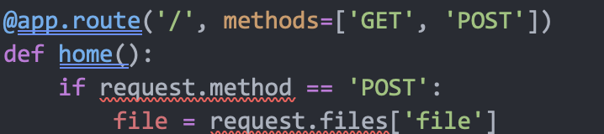

The `home()` function is the main route of the web application. It takes GET and POST requests from the user's web browser. If the request is a POST request, it retrieves the uploaded image from the form data, processes the image to classify the soil type, and renders the result to the user. If the request is a GET request, it displays the home page of the web application, which includes an upload form for the user to submit an image.

**9. Upload Functionality:**

The `file = request.files['file']` line retrieves the uploaded file from the POST request.

**10. Exception Handling:**

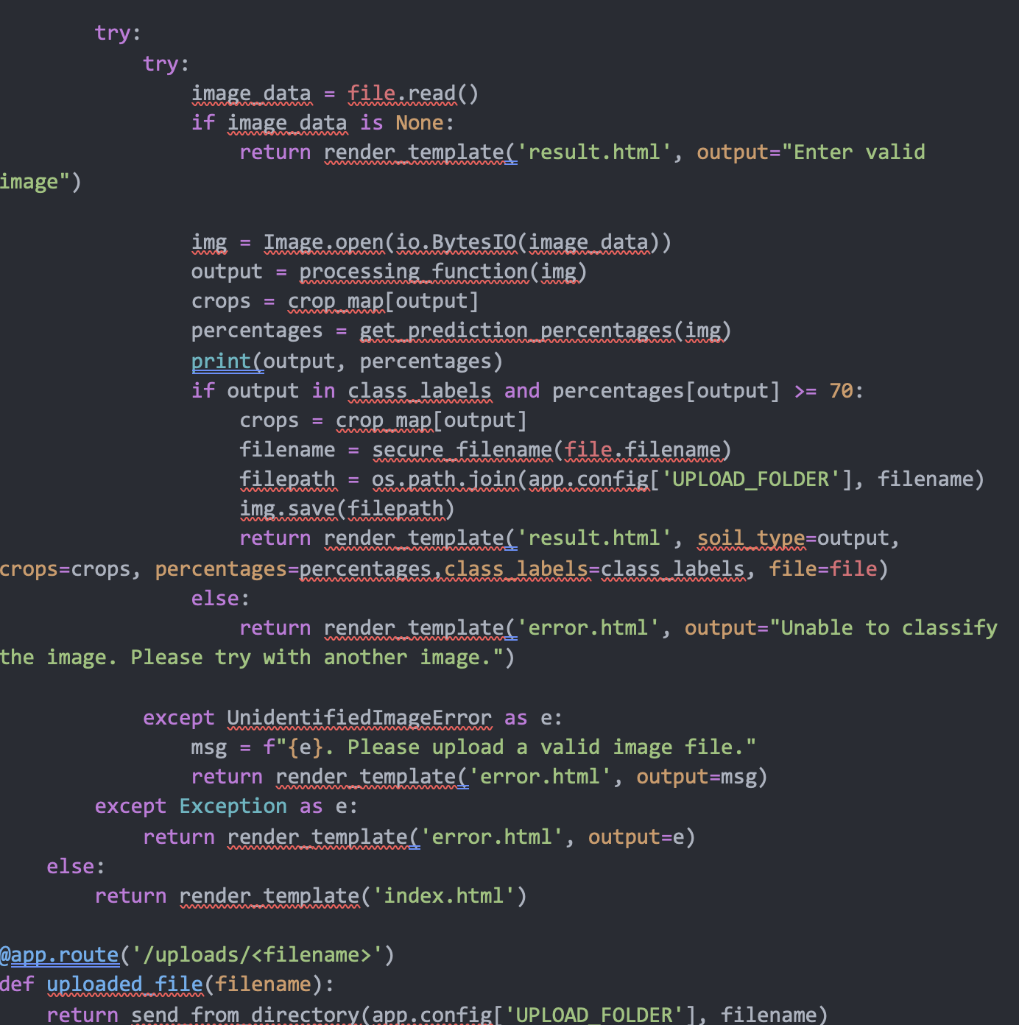

The `try` block is used to catch errors that may occur while processing the uploaded image. The `except` block catches and handles `UnidentifiedImageError` exceptions, which occur when the uploaded file is not an image.

**11. Image Processing:**

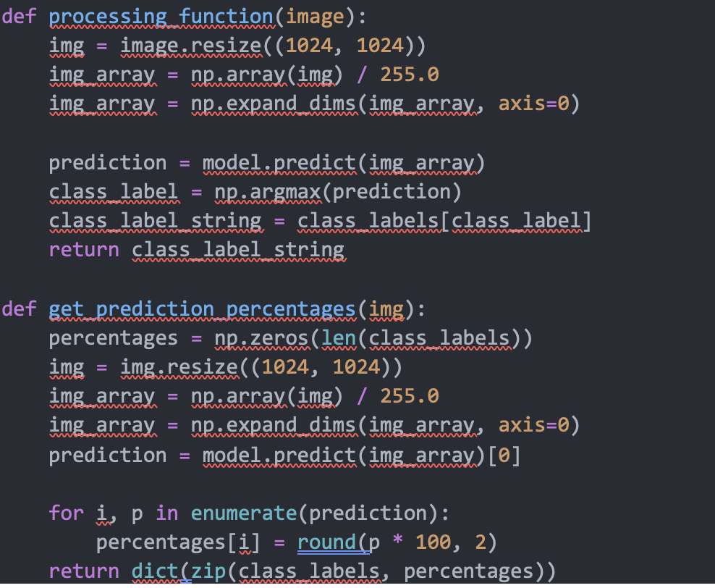

The `img = Image.open(io.BytesIO(image_data))` line converts the image data into a `PIL Image` object. The `processing_function(img)` processes the image and returns the predicted soil type based on the input image. The `get_prediction_percentages(img)` function returns the probability of each soil type in percentages.

**12. Image Resizing:**

Both `processing_function()` and `get_prediction_percentages()` functions resize the image to 1024x1024 pixels to ensure that the input to the model has a consistent size.

**13. Classification:**

The function processing_function() performs several steps to process an input image. Firstly, it resizes the image to 1024x1024 pixels and normalizes it. Then, it passes the processed image through a pre-trained machine learning model to predict the soil type. Finally, it returns the predicted soil type as a string.

**14. Prediction Probability:**

The `get_prediction_percentages()` function takes the input image, resizes it to 1024x1024 pixels, normalizes it, and passes it through the pre-trained machine learning model to predict the probabilities of the four soil types. It then returns the probabilities as a dictionary with the soil type names as keys and the probabilities as values.

**8.5 Description of Technology Used**

The technologies that we used in this project include:

* CNNs
* TensorFlow
* Keras
* PIL (Python Imaging Library)
* NumPy
* CV2
* Flask

**CNNs:**

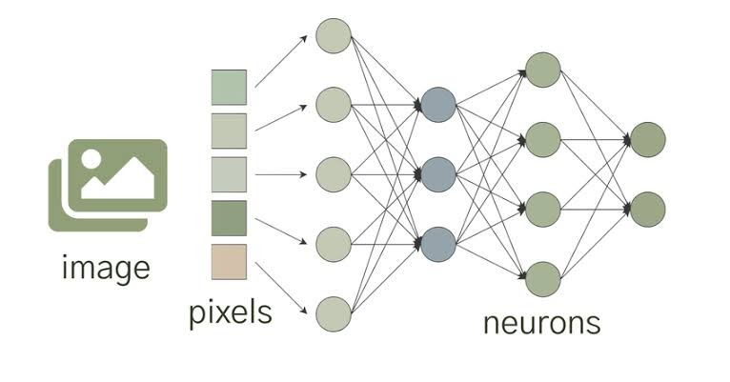

* CNNs are a type of neural network that is particularly suited to image processing tasks. In this project, CNNs are used to extract features from the Landsat-8 images that can be used to classify the different soil types.
* The Convolutional Neural Network (CNN) also employs a loss function, and standard techniques used in neural networks are still applicable.
* Neural networks are inspired by the structure of the human brain, consisting of interconnected learning units or neurons.
* These neurons are trained to transform input signals (e.g., an image of red soil) into corresponding output signals (e.g., labeling the image as a "Red soil"), forming the foundation of automated recognition.

**TensorFlow:**



* TensorFlow is an open-source software library best used for Deep Learning problems developed by Google that is used for building and training machine learning models. In this project, it is used to implement the CNN model.
* The Multidimensional arrays or Tensors, the data given to the TensorFlow, are crucial in working with huge loads of data.
* TensorFlow operates on data flow graphs composed of interconnected nodes and edges. By using this graph-based approach, TensorFlow makes it simpler to distribute its code across a network of computers, including those with GPUs.

**Keras:**



* Keras is an API for neural networks that operates at a high-level and is built upon TensorFlow. Its purpose is to provide a user-friendly interface for constructing deep learning models, which is why it was used in this project to develop the CNN model.
* Keras was created by Google, and it is coded in Python. It delivers a straightforward method for implementing neural networks, and it supports various backend computations for neural networks.
* Keras is easy to use due to its high-level abstraction and Python-based front-end, as well as its ability to select from several backend computation options. While this makes it slower than other deep learning frameworks, it is an ideal option for beginners.

**PIL:**



* PIL is a Python library that facilitates the opening, manipulation, and saving of a broad range of image file formats. It is utilized in this project to read and preprocess the Landsat-8 images before inputting them into the CNN model.
* PIL, also known as the Python Imaging Library, is a module that empowers image processing within the Python interpreter. This library delivers numerous features, such as support for various file formats, a high-performance internal representation, and powerful image processing capabilities. The library's core image processing tools aim to provide quick access to data stored in fundamental pixel formats, creating a solid foundation for a comprehensive image processing toolkit.

**NumPy:**



* NumPy is a Python library that specializes in numerical computing. It is utilized to convert the Landsat-8 images into image arrays in this project.
* NumPy is a critical library for scientific computing in Python. It features a multi-dimensional array object, along with other relevant objects like matrices and masked arrays. Additionally, it provides several tools for swift manipulation of arrays, including mathematical, logical, shape manipulation, sorting, selection, input/output, discrete Fourier transforms, basic linear algebra, fundamental statistical operations, and stochastic simulation..

**CV2:**



* In this project, CV2 is utilized to preprocess the Landsat-8 images before inputting them into the CNN model. CV2 is a Python library that provides support for computer vision tasks.
* OpenCV-Python is a specific set of bindings within the Python library created to address computer vision tasks. The library contains a variety of methods, including "cv2.imread()" which is designed to load images from a specified file. If the image file is not readable for any reason such as a missing file, incorrect permissions, or an unsupported or invalid format, the method returns an empty matrix.

**Flask:**



* Flask is a lightweight web framework for Python that is used in this project to build a web application that allows users to upload and classify Landsat-8 images using the trained CNN model.
* The trained classification model is connected to the front-end web application using the Flask framework.

**9. Results and Analysis:**

We have used Google Colab for training the deep network. The figures, “Fig.6”, “Fig.8”, “Fig.10”, “Fig.12” show the images taken from the satellite dataset, whereas the figures “Fig.7”, “Fig.9”, “Fig.11”, “Fig.13”, show the images that have been processed using Python Imaging Library with a resolution of 1024x1024.

|  |  |
| --- | --- |
|  |  |

Fig. 6 Alluvial soil Image from satellite Fig.7 Processed Alluvial soil Image.

|  |  |
| --- | --- |
| Graphical user interface  Description automatically generated with low confidence F Fig. 8 Black soil Image from satellite | A screenshot of a video game  Description automatically generated with medium confidence  F Fig. 9 Processed Black soil Image |

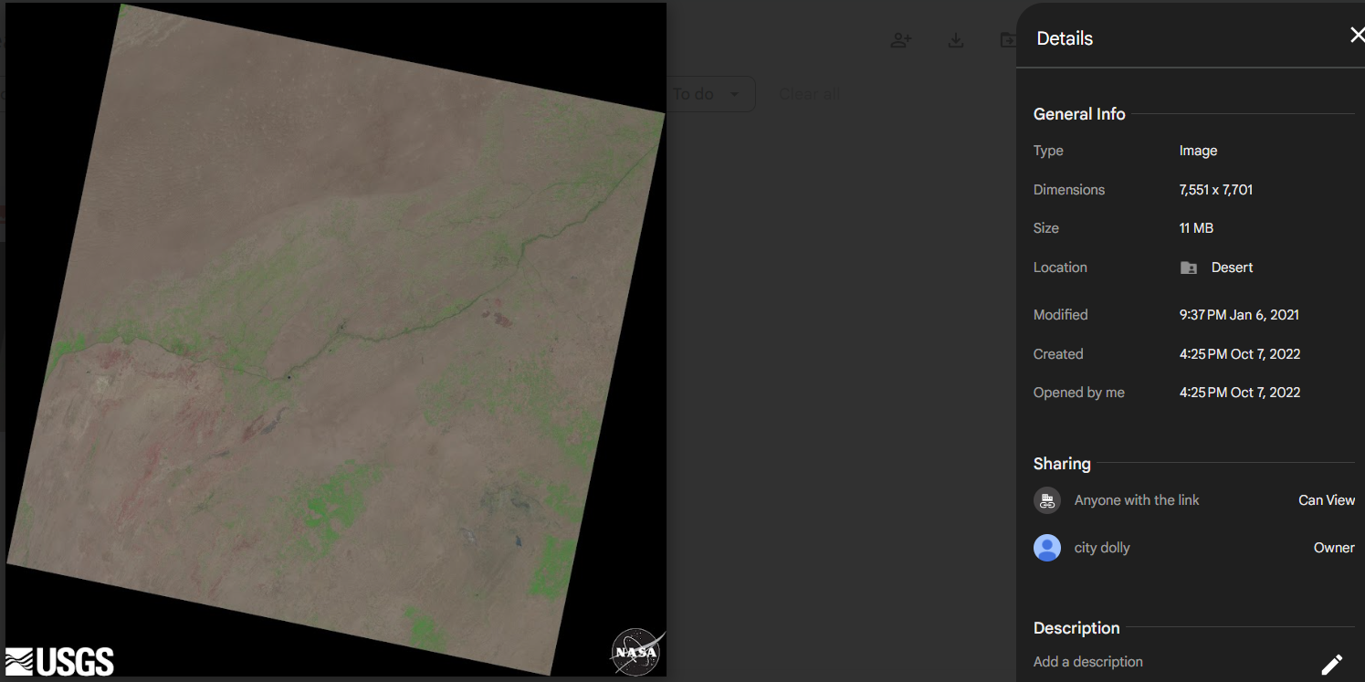 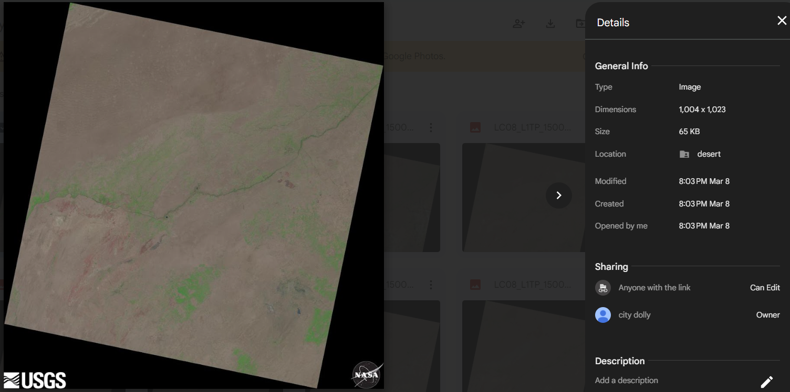

Fig. 10 Desert soil Image from satellite Fig. 11 Processed Desert soil Image

|  |  |
| --- | --- |
|  |  |

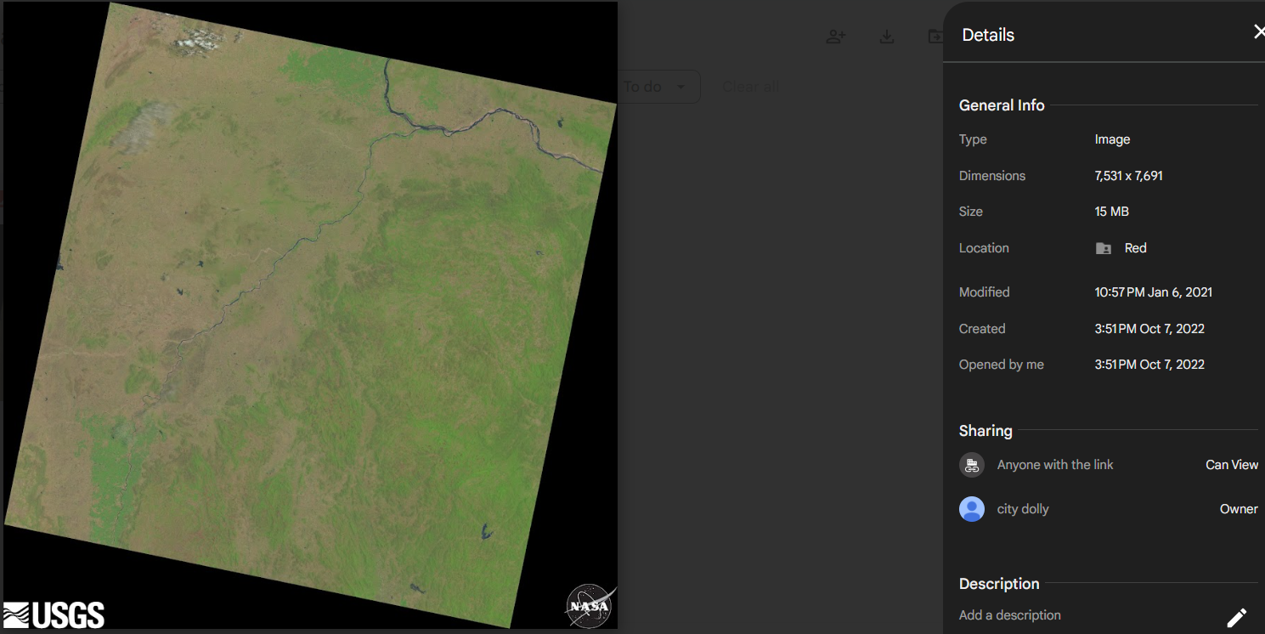 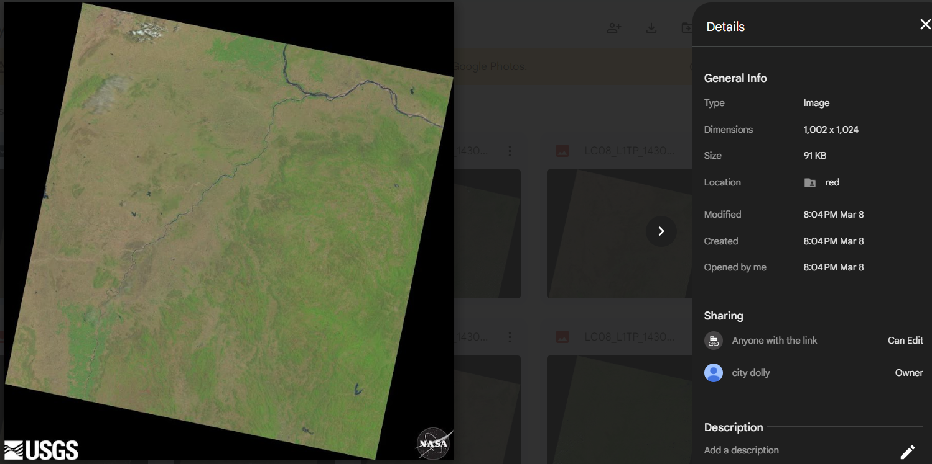

Fig. 12 Red soil Image from satellite Fig. 13 Processed Red soil Image

The training set of 320 images was used to train the model and validated using the validation set of 80 images. With a learning rate of 0.0001 and a batch size of 2, the Adam optimizer was used to train the model. After training the model for 10 epochs, the best model was chosen based on the highest validation accuracy.

The performance of the model was evaluated using the testing set of 80 images. This model achieved an overall accuracy of 97.50% on the testing set using “(2)”

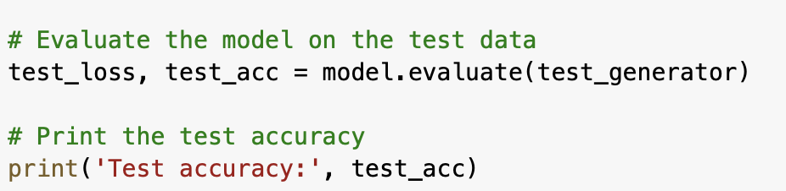

The results of our machine learning model are promising in terms of accuracy and model loss. Our model achieved a high level of accuracy, having an overall accuracy rate of 97.50% on the testing set. This indicates that our model was able to accurately classify soil types using LANDSAT-8 images.

Additionally, our model demonstrated low model loss, indicating that it was able to effectively minimize errors during the training process. These results highlight the robustness and reliability of our deep learning-based approach for soil type classification, making it a valuable tool for various practical applications in agriculture, government, and research domains.

|  |  |
| --- | --- |
|  |  |

Fig. 14 Accuracy plot for the deep learning modelFig. 15 Loss plot for the deep learning model

Deep Neural Network has the model summary as shown in Table 1



|  |  |  |
| --- | --- | --- |
| ***Layer (type)*** | ***Output Shape*** | ***Param*** |
| conv2d (Conv2D) | (None, 1022, 1022, 32) | 896 |
| max_pooling2d (MaxPooling2D) | (None, 511, 511, 32) | 0 |
| conv2d_1 (Conv2D) | (None, 509, 509, 64) | 18496 |
| max_pooling2d_1 (MaxPooling2D) | (None, 254, 254, 64) | 0 |
| flatten (Flatten) | (None, 4129024) | 0 |
| dense_6 (Dense) | (None, 64) | 264257600 |
| dense_7 (Dense) | (None, 4) | 260 |
| **Total params:** 264,277,252  **Trainable params:** 264,277,252  **Non-trainable params:** 0 | | |

Table 1. Summary of the parameters of the deep learning model

**Web Application**

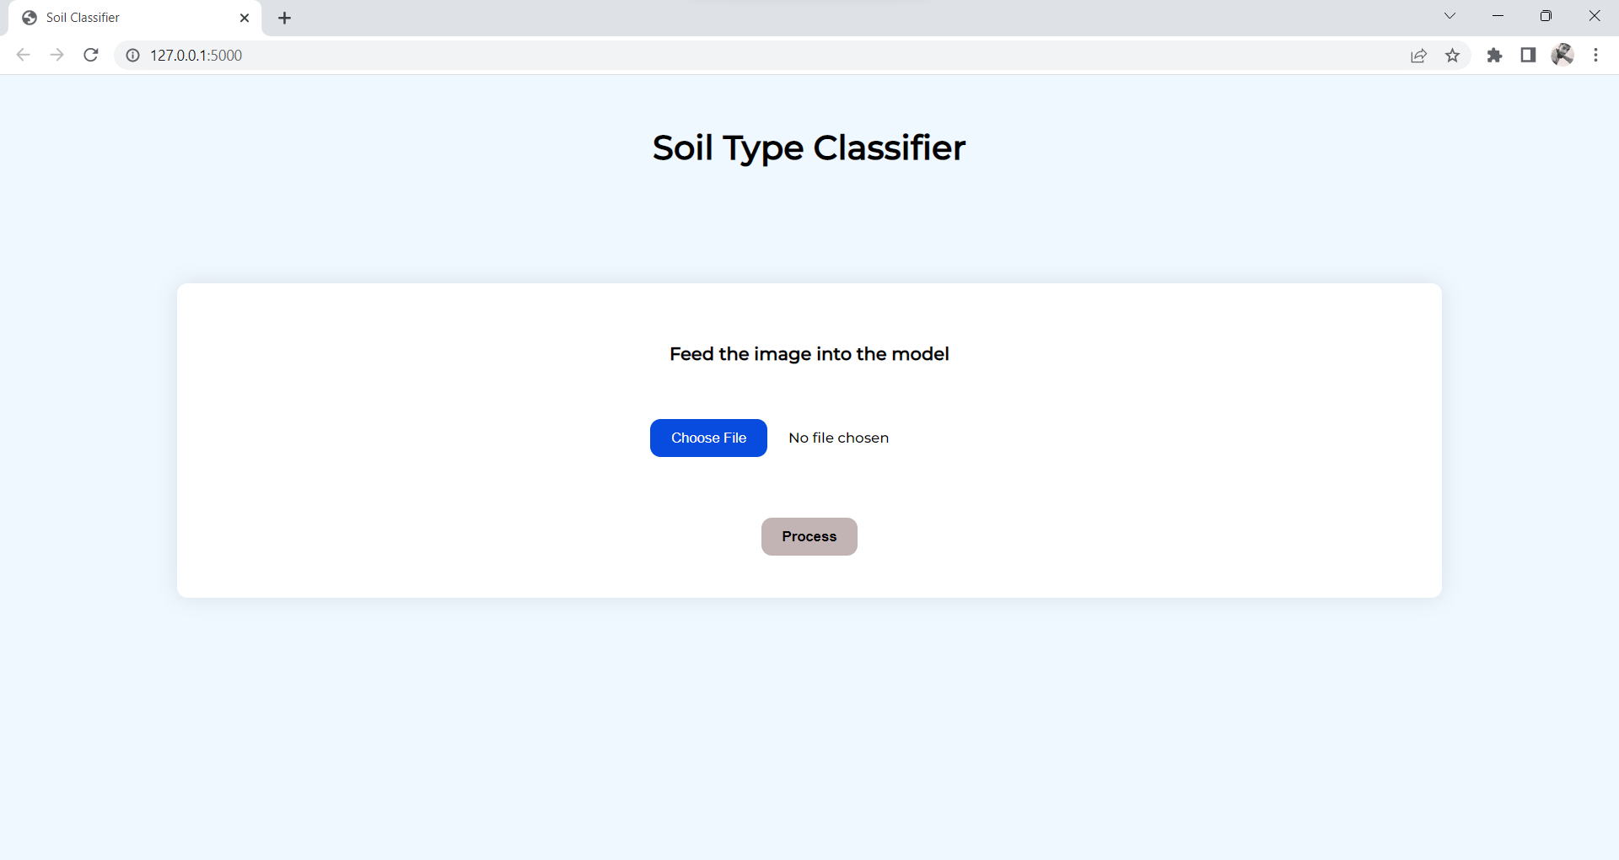

Fig. 16 Snapshot of the Web Application

**Application Flow – Valid Image/Positive Flow**

* User has an option to upload the image from the local disk.
* After choosing the image file user should click on Process button to submit the form.
* If the image is valid after processing the image the results are displayed.
* Results include the confidence percentages of all four classes.
* Uploaded image is also displayed for reference.
* The output of the prediction model is displayed.
* Crop suggestions for predicted soil type are displayed.
* Button is provided to test for another image.
* User is taken back to the main page to upload the image.

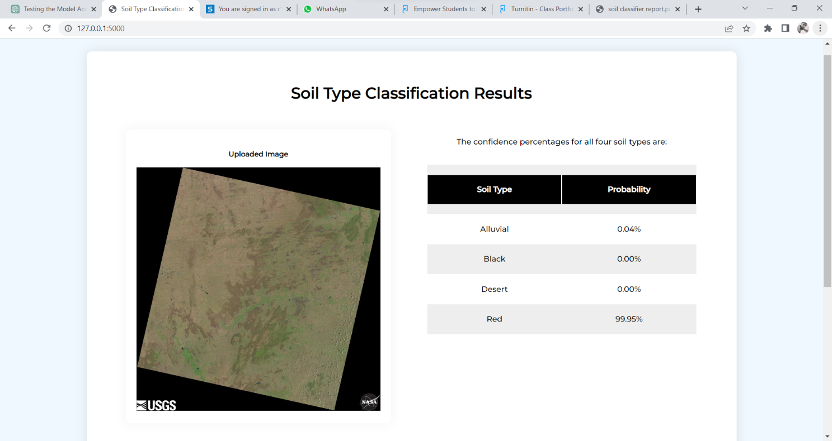

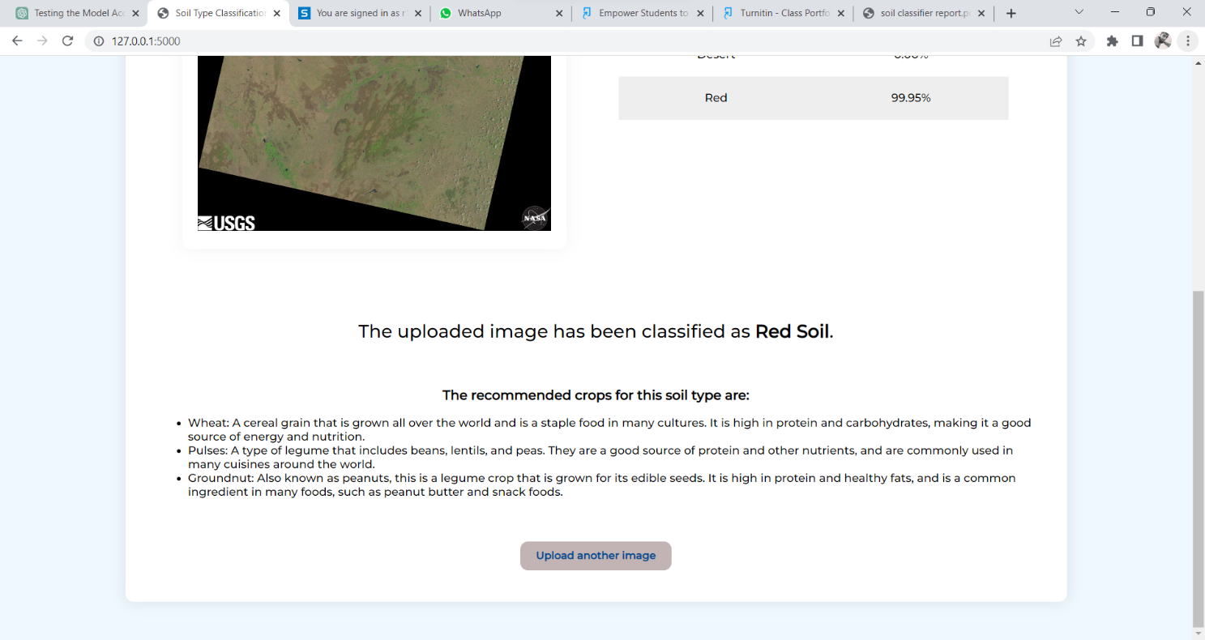

Fig. 17,18 Snapshot of the Web Application once a valid image is processed.

**Application Flow – Invalid Image/Negative Flow**

* User has an option to upload the image from the local disk.
* After choosing the image file user should click on Process button to submit the form.
* If the image format is invalid the error message is displayed.
* If the image is valid but the confidence percentage is less than 70 user is asked to submit another image.
* Button is provided to test for another image.
* User is taken back to the main page to upload the image.

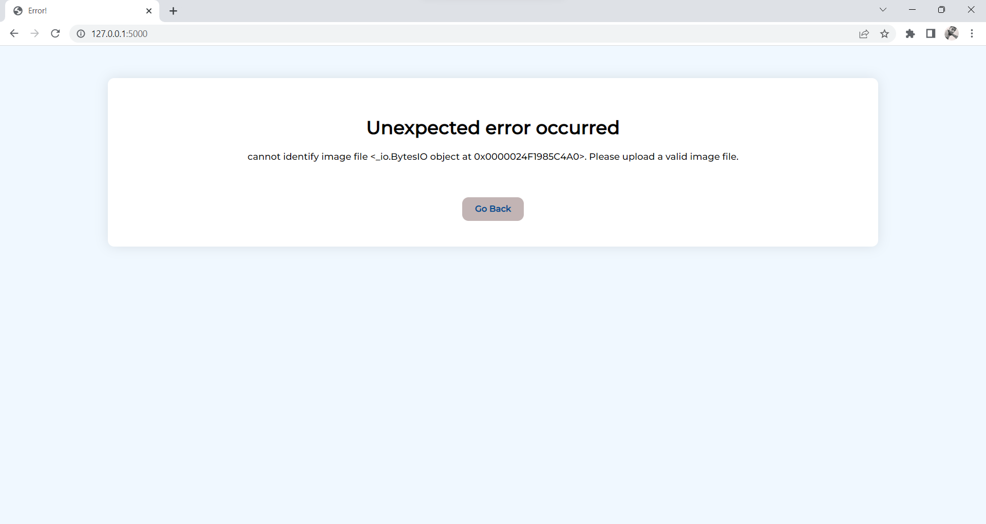

Fig. 19 Snapshot of the Web Application throwing an error for inputting an invalid image.

**10. Cost of the Project**

The software and tools we have used are open source and free.

Miscellaneous expenses: 2500/-

**11. Conclusions:**

In this study, we proposed a deep learning-based approach for classifying soil types using LANDSAT-8 images. The proposed model achieved an overall accuracy of 97.50% on the testing set, which demonstrates the effectiveness of the proposed approach. The proposed approach can be used by farmers, government agencies, private businesses, and researchers to predict soil types and their physical and chemical properties. Further research can be conducted to extend the proposed approach to other regions and soil types.

* Classification into different soil classes using traditional and deep learning methods was successfully performed on the downloaded dataset and the above-mentioned results were obtained.
* We got an understanding of the traditional clustering and classification methods as well as the deep learning classification method.
* We also learnt about various data pre-processing techniques.

The inaccuracy in results can be attributed to the following reasons:

* Inaccuracy in segmenting soil and vegetation/cloud cover from the images
* Small data set size (800 images used)
* The image block size is too large.

**12. Project Limitations and Future Enhancements**

The limitations of our model and the scope for the improvements are as follows:

* The model can be extended to work on classifying other soil types apart from the above identified soil types.
* Further work can be done on improving the model’s accuracy.
* Redefine model’s architecture to process large datasets.
* Enhancements can be made to the model to identify mixed soil types.

**13. References:**

[1]. Heryadi, Y., Miranda, E. (2020). Land Cover Classification Based on Sentinel-2 Satellite Imagery Using Convolutional Neural Network Model: A Case Study in Semarang Area, Indonesia. In: Huk, M., Maleszka, M., Szczerbicki, E. (eds) Intelligent Information and Database Systems: Recent Developments. ACIIDS 2019. Studies in Computational Intelligence, vol 830. Springer, Cham.<https://doi.org/10.1007/978-3-030-14132-5_15>

[2]. N. S. Kumar, S. M. Anouncia and M. Prabu,“Application of Satellite Remote Sensing to find Soil Fertilization by using Soil Colour”, International Journal of Online Engineering (iJOE), vol. 9, no. 2, 2013

[3]. M. A.Hamada, Y. Kanat and A. E. Abiche, “Multi-Spectral Image Segmentation Based on the K-means Clustering”, International Journal of Innovative Technology and Exploring Engineering (IJITEE), Vol. 9, no. 2, 2019

[4]. T. Z. Phyo, A. S. Khaing and H. M. Tun, “Classification Of Cluster Area For satellite Image”, International Journal of Scientific & Technology Research, Vol. 4, 2015

[5]. S. A. Siddiqui and N. Fatima, ‘Indian Soils: Identification and Classification’, Earth Science India, vol. 10, no. III, 2017, pp-1-14

[6]. V. Poliyapram, N. Imamoglu and R. Nakamura, "Deep Learning Model for Water/Ice/Land Classification Using Large-Scale Medium Resolution Satellite Images," IGARSS 2019 - 2019 IEEE International Geoscience and Remote Sensing Symposium, 2019, pp. 3884-3887, doi: 10.1109/IGARSS.2019.8900323.

[7]. L. B. Rananavare and S. Chitnis, "Monocot Crop Yield Prediction using Sentinel-2 Satellite Data," *2022 IEEE 3rd Global Conference for Advancement in Technology (GCAT), Bangalore, India, 2022, pp. 1-6, doi: 10.1109/GCAT55367.2022.9971820.*

[8]. *X. Gao, T. Lu, P. Liu and Q. Lu, "A soil moisture classification model based* on SVM used in agricultural WSN," 2014 IEEE 7th Joint International Information Technology and Artificial Intelligence Conference, Chongqing, China, 2014, pp. 432-436, doi: 10.1109/ITAIC.2014.7065086.

[9]. S. Bousbih *et al*., "Sentinel-1 and Sentinel-2 Data for Soil Moisture and Irrigation Mapping Over Semi-Arid Region," *IGARSS 2019 - 2019 IEEE International Geoscience and Remote Sensing Symposium*, Yokohama, Japan, 2019, pp. 7022-7025, doi: 10.1109/IGARSS.2019.8897883.

[10]. Y. Zhou, W. Wu, H. Wang, X. Zhang, C. Yang and H. Liu, "Identification of Soil Texture Classes Under Vegetation Cover Based on Sentinel-2 Data With SVM and SHAP Techniques," in *IEEE Journal of Selected Topics in Applied Earth Observations and Remote Sensing*, vol. 15, pp. 3758-3770, 2022, doi: 10.1109/JSTARS.2022.3164140.

[11]. <https://earthexplorer.usgs.gov/>

**14. Copies of Articles**

**14.1 Project Proposal** **Showcase**

Accepted and presented at IEEE CCEM 2022 Student Project Showcase 

**14.2 Conference Submission**

IACIT- 2023 Conference – Accepted and Presented for Submission 

**14.2.1 Accepted Paper plagiarism summary**



**Final Report plagiarism summary**



Paper titled “Website Development for Soil Classification Using Deep CNN “communicated to 4th EAI International Conference on Cognitive Computing and Cyber Physical Systems 2023.